

Advanced IoT-Based Water pH Monitoring System
Using ESP32 and High-Precision pH Sensor

A CAPSTONE PROJECT REPORT
A Capstone Project Report submitted in partial fulfilment of the requirements for the Course of

ECA1407 EMBEDDED SYSTEM
to the award of the degree of

BACHELOR OF ENGINEERING IN
ELECTRONICS AND COMMUNICATION ENGINEERING

Submitted by
K Subrahmanyam (192312521)
Esarajula Yedukondalu (192312315)
Amaravathi Dileep Kumar (192372134)
Pooja V (192512463)
Ramyasree R (192512312)

Under the Supervision of
Dr R Yuvaraj
SIMATS ENGINEERING
Saveetha Institute of Medical and Technical Sciences Chennai-602105
SEPTEMBER 2026

SIMATS ENGINEERING
Saveetha Institute of Medical and Technical Sciences Chennai-602105

BONAFIDE CERTIFICATE

This is to certify that the Capstone Project entitled “Advanced IoT-Based Water pH Monitoring System Using ESP32 and High-Precision pH Sensor” has been carried out by K Subrahmanyam (192312521), Esarajula Yedukondalu (192312315), Amaravathi Dileep Kumar (192372134), Pooja V (192512463), Ramyasree R (192512312) under the supervision of Dr R Yuvaraj and is submitted in partial fulfilment of the requirements for the current semester of the B.Tech Electronics and Communication Engineering program at Saveetha Institute of Medical and Technical Sciences, Chennai.

COURSE COORDINATOR COURSE FACULTY
Dr .G.P.BHARATHI, Mr.R Yuvaraj,
Professor Assistant Professor (Sr.Gd)
Electronics and Electronics and
Communication Communication
Engineering Engineering
SIMATS Engineering, SIMATS Engineering,
SIMATS, Chennai – 602105. SIMATS, Chennai – 602105.

SIMATS ENGINEERING
Saveetha Institute of Medical and Technical Sciences Chennai-602105

DECLARATION
We, K Subrahmanyam (192312521), Esarajula Yedukondalu (192312315), Amaravathi Dileep Kumar (192372134), Pooja V (192512463), Ramyasree R (192512312) of the ECE, SIMATS Engineering, Saveetha Institute of Medical and Technical Sciences, Chennai, hereby declare that the Capstone Project Work entitled “Advanced IoT-Based Water pH Monitoring System Using ESP32 and High-Precision pH Sensor” is the result of our own bonafide efforts. To the best of our knowledge, the work presented herein is original, accurate, and has been carried out in accordance with the principles of engineering ethics and academic integrity. All sources, references, data, and other materials used in the project have been appropriately acknowledged. We further declare that the data, results, analysis, and findings presented in this report have not been fabricated, falsified, or manipulated. Any external tools, software, datasets, computational resources, or AI-assisted tools used during the project have been appropriately disclosed. We confirm that all applicable ethical, academic, institutional, and professional requirements have been duly followed throughout the planning, execution, analysis, and documentation of the project.
Place:
Date:

Signature of the Students with Names
K Subrahmanyam (192312521)
Esarajula Yedukondalu (192312315)
Amaravathi Dileep Kumar (192372134)
Pooja V (192512463)
Ramyasree R (192512312)

SIMATS ENGINEERING
Saveetha Institute of Medical and Technical Sciences Chennai-602105

Individual Contribution Statement
(Mandatory for all team projects)

Student Name / Register No. | Specific Responsibilities | Design & Development Contribution | Testing & Analysis Contribution | Report Contribution | Approx. Contribution (%)
Student 1 | Hardware setup and sensor interfacing | ESP32 and pH sensor connection | Sensor testing and ADC readings | Chapter 3 & 4 | __%
Student 2 | Software development | ESP32 programming and pH calculation | Code testing and calibration | Chapter 4 | __%
Student 3 | Blynk and IoT integration | Wi-Fi and Blynk dashboard | Notification and monitoring testing | Chapter 4 | __%
Student 4 | Documentation and analysis | Circuit/diagram preparation | Result and graph analysis | Chapter 1, 2 & 5 | __%
Total |  |  |  |  | 100%

ABSTRACT
Water quality monitoring is important for identifying whether water is acidic, neutral, or alkaline. Conventional pH measurement methods often require manual observation and do not provide continuous remote monitoring. Therefore, there is a need for a simple and IoT-based system that can measure the pH level of water and provide the result to the user remotely.
This project presents an Advanced IoT-Based Water pH Monitoring System using ESP32 and a high-precision pH sensor. The proposed system uses a pH probe and sensor module to detect the pH of a water sample and generate an analog output. The analog signal is provided to the ESP32 through its ADC input. The ESP32 reads the ADC value, converts it into voltage, and calculates the corresponding pH value using an experimental calibration formula.
To improve the stability of the readings, multiple ADC samples are collected and averaged before calculating the pH value. The calculated pH is then transmitted through the ESP32's Wi-Fi connection to the Blynk IoT platform. The Blynk dashboard provides a gauge and graphical representation of the measured pH, allowing the user to monitor the water condition remotely. The system also includes an alert mechanism for abnormal pH conditions. In the implemented system, pH values below 6.5 and above 8.5 are treated as abnormal conditions and can trigger Blynk notifications.
The prototype was tested using different water samples, including acidic water, normal water, and baking-soda water, to observe changes in the measured pH values. The experimental readings demonstrated that the system can detect changes in pH and display them through the IoT dashboard. The developed system provides a low-cost and practical approach for water pH monitoring with remote visualization and abnormal-condition alerts.
Keywords: ESP32, pH Sensor, Water Quality Monitoring, ADC, Blynk IoT, IoT Monitoring

TABLE OF CONTENTS
Sl.  No | Title | Page  No
i | CERTIFICATE FROM THE SUPERVISOR | ii
ii | DECLARATION BY THE CANDIDATE | iii
Iii | INDIVIDUAL CONTRIBUTION STATEMENT | iv
iv | ABSTRACT | v
v | LIST OF FIGURES | vi
vi | LIST OF TABLES | vii
vii | LIST OF ABBREVIATIONS | viii
1 | CHAPTER 1: Introduction
2 | CHAPTER 2: Literature Review
3 | CHAPTER 3: Engineering Design & Trade-offs, Sustainability, Ethics, Safety, Risk & Security
4 | CHAPTER 4: Implementation, Testing & Results, Project Management
5 | CHAPTER 5: Conclusion & Reflection
 | References
 | Appendices

Figure No. | Figure Name | Page No.
Fig. 3.1 | System Block Diagram | ___
Fig. 3.2 | Circuit Diagram | ___
Fig. 4.1 | Hardware Setup of the Proposed System | ___
Fig. 4.2 | Serial Monitor – ADC, Voltage and pH Readings | ___
Fig. 4.3 | Blynk IoT Dashboard | ___
Fig. 4.4 | pH Graph for Different Water Samples | ___

LIST OF TABLES
Table No. | Table Name | Page No.
Table 3.1 | Functional and Non-Functional Requirements | ___
Table 3.2 | Design Specifications | ___
Table 3.3 | Alternative Solutions Evaluation | ___
Table 3.4 | Trade-off Analysis | ___
Table 3.5 | Sustainability, Ethics, Safety and Security Considerations | ___
Table 3.6 | Risk Register | ___
Table 4.1 | Components and Resources Used | ___
Table 4.2 | Test Plan and Verification | ___
Table 4.3 | Experimental pH Readings | ___
Table 4.4 | Comparison of Water Samples | ___
Table 4.5 | Strengths and Limitations | ___
Table 4.6 | Project Cost | ___

LIST OF ABBREVIATIONS / SYMBOLS
Symbol | Description | Unit
pH | Potential of Hydrogen | —
ESP32 | Embedded System with Wi-Fi and Bluetooth | —
ADC | Analog-to-Digital Converter | —
IoT | Internet of Things | —
Wi-Fi | Wireless Fidelity | —
V | Voltage | Volt (V)
PO | Analog pH Sensor Output | Volt (V)
TO | Temperature Output | Volt (V)
Blynk | IoT Cloud Monitoring Platform | —
GND | Ground | —
GPIO | General-Purpose Input/Output | —
kΩ | Kiloohm | Ω

CHAPTER 1 – INTRODUCTION AND ENGINEERING PROBLEM
1.1 Background
Water quality is an important factor in domestic, environmental, and industrial applications. pH (Potential of Hydrogen) is an important parameter used to indicate whether water is acidic, neutral, or alkaline.
Traditional pH measurement generally requires a user to manually observe the measurement. Such an approach does not provide convenient continuous monitoring or remote access to the measured values.
The proposed project develops an IoT-based water pH monitoring system using an ESP32 and pH sensor. The system measures the pH of a water sample, processes the sensor signal using the ESP32, and sends the calculated pH value to the Blynk IoT platform for remote monitoring.
1.2 Need for the Project
- Water pH needs to be monitored to identify acidic or alkaline conditions.
- Manual measurement does not provide convenient continuous monitoring.
- Remote access to the measured pH value can improve ease of monitoring.
- An IoT-based system can display the measured value through a mobile dashboard.
- Abnormal pH conditions can be indicated through an alert mechanism.
1.3 Problem Statement
Traditional water pH measurement requires manual testing and does not provide continuous remote monitoring or immediate notification when the water pH becomes abnormal. Therefore, a low-cost IoT-based system is required to measure water pH, monitor the value remotely, and provide alerts for abnormal conditions.
1.4 Project Aim
To develop an IoT-based water pH monitoring system using ESP32 and a pH sensor for real-time measurement, remote monitoring through Blynk, and abnormal-pH notification.

1.5 Project Objectives
- To design and develop a water pH monitoring system using an ESP32 and pH sensor.
- To acquire the analog sensor signal through the ESP32 ADC.
- To convert the ADC reading into voltage and calculate the corresponding pH value.
- To display the measured pH value on the Blynk IoT platform.
- To test the system using different water samples and observe the resulting pH values.
- To provide an alert when the pH value goes below 6.5 or above 8.5.
1.6 Scope
Included
- Water pH measurement using a pH probe and sensor module.
- ESP32-based ADC reading and pH calculation.
- Wi-Fi communication with Blynk.
- Remote pH value display and graphical monitoring.
- Abnormal pH alert mechanism.
- Testing with different water samples.
Excluded
- Automatic adjustment of water pH.
- Temperature-based pH compensation.
- Chemical treatment of water.
- Complete water-quality analysis beyond pH.
Assumptions
- The pH probe and sensor module are properly connected.
- The sensor is calibrated before measurement.
- Wi-Fi is available for Blynk monitoring.
- The water samples are suitable for pH measurement.
Boundary Conditions
- The implemented pH display is limited to 0–14.
- The alert thresholds are 6.5 and 8.5.
- The system monitors pH only and does not measure other water-quality parameters.
The format requires the scope to clearly state what is included, excluded, assumptions, and boundary conditions.
Capstone Project Report - New F…
1.7 Expected Engineering Outcome
The expected outcome is a working prototype of an IoT-based water pH monitoring system that:
- Measures water pH using a pH sensor.
- Processes the analog signal using ESP32.
- Calculates and displays the pH value.
- Sends data to the Blynk IoT platform.
- Provides remote monitoring through the dashboard.
- Generates an alert when the measured pH crosses the predefined limits.

CHAPTER 2 – LITERATURE REVIEW AND EXISTING SOLUTIONS
2.1 Review Method
The literature review was carried out to understand existing methods and technologies used for water pH measurement and monitoring. The review considered conventional pH measurement methods, sensor-based systems, microcontroller-based monitoring, and IoT-based water-quality monitoring systems.
The review focused on the sensing method, data acquisition, controller used, communication method, remote monitoring capability, and alert features. These aspects were considered to identify the limitations of existing approaches and determine suitable features for the proposed ESP32-based water pH monitoring system.
2.2 Review of Existing Work
2.2.1 Conventional pH Measurement
Conventional pH measurement systems use a pH electrode or probe connected to a pH meter. The probe senses the chemical condition of the water and the meter provides the corresponding pH reading.
These systems are useful for direct measurement but generally require the user to be physically present to observe the reading. They do not inherently provide IoT connectivity, remote monitoring, or mobile notifications.
2.2.2 Microcontroller-Based pH Monitoring
Microcontroller-based systems use a pH sensor together with a controller to acquire and process the sensor output. The analog signal from the sensor can be converted into a digital value using an ADC and then processed to obtain the pH value.
This approach reduces manual measurement and allows automated data acquisition. However, a basic microcontroller system may not provide remote monitoring unless a suitable communication interface is added.
2.2.3 IoT-Based Water Monitoring
IoT-based monitoring systems combine sensors, a microcontroller, wireless communication, and a cloud or mobile platform. Sensor measurements can be transmitted through Wi-Fi and displayed remotely.
2.3 Comparative Analysis
The following table compares the existing approaches with the proposed system.
Existing Approach | Advantages | Limitations | Relevance to Proposed Work
Conventional pH Meter | Simple and direct pH measurement. | Requires manual observation and does not provide remote monitoring. | Provides the basic principle of water pH measurement.
Microcontroller-Based pH System | Provides automated sensor reading and data processing. | Remote monitoring may not be available. | Forms the basis for ESP32-based signal acquisition.
IoT-Based Water Monitoring | Supports remote monitoring and online data visualization. | Requires Wi-Fi/internet connectivity. | Provides the IoT approach used in our project.
Commercial Digital pH Meter | Convenient and easy to use for individual measurements. | Limited customization for IoT monitoring and notifications. | Provides a reference for comparing measurement functionality.
Proposed ESP32 + pH + Blynk System | Combines pH sensing, processing, remote monitoring, graph display, and alerts. | Depends on sensor calibration and Wi-Fi availability. | Selected approach for the proposed project.

Table 2.1 – Comparative Analysis of Existing and Proposed Approaches
2.4 Research / Engineering Gap
The reviewed approaches show that conventional pH meters provide direct measurements but generally depend on manual observation. Microcontroller-based systems can automate data acquisition, while IoT-based systems provide remote access to measurements.
The engineering gap addressed by this project is the integration of pH sensing, ESP32-based ADC processing, Wi-Fi communication, Blynk visualization, and abnormal-pH notification into a single low-cost prototype.
2.5 Proposed Contribution
The proposed project develops an IoT-based water pH monitoring system using an ESP32 and pH sensor. The sensor produces an analog signal that is acquired by the ESP32 through its ADC, converted into voltage, and used to calculate the corresponding pH value using the experimental calibration formula.
The calculated pH value is transmitted through Wi-Fi to the Blynk IoT platform, where it can be monitored using a dashboard and graph. The system also provides an alert mechanism when the measured pH crosses the predefined limits.

CHAPTER 3 – ENGINEERING DESIGN & TRADE-OFFS, SUSTAINABILITY, ETHICS, SAFETY, RISK & SECURITY
3.1 Requirements
3.1.1 Stakeholder / User Requirements
The system is intended to provide a simple method for monitoring water pH and viewing the measured value remotely.
- The user should be able to measure the pH of a water sample.
- The system should provide a readable pH value.
- The pH value should be available on the Blynk dashboard.
- The system should allow monitoring of pH variation through a graph.
- The system should provide an alert when the pH crosses the predefined limits.
Table 3.1 – Functional and Non-Functional Requirements
Requirement Type | Requirement | Measurable Target
Functional | Measure water pH | pH value displayed
Functional | Read sensor output | ADC reading through GPIO 32
Functional | Calculate pH | pH calculated from sensor voltage
Functional | Remote monitoring | Data displayed on Blynk
Functional | Abnormal pH alert | Alert below 6.5 or above 8.5
Non-Functional | Readability | Clear pH display
Non-Functional | Reliability | Stable readings using averaged samples
Non-Functional | Connectivity | Wi-Fi communication with Blynk
3.2 Constraints & Applicable Standards
The main constraints considered in the project are sensor calibration, ADC measurement limitations, Wi-Fi availability, and safe electrical interfacing.
For standards, the report format specifically says to name the specific standard and explain how it is applied, rather than simply stating that IEEE standards were followed.
Table 3.2 – Applicable Standards and Constraints
Standard / Constraint | Requirement | How Applied in This Project
IEEE 802.11 | Wireless LAN communication | ESP32 uses Wi-Fi to communicate with the Blynk platform.
Sensor calibration | Accurate conversion of sensor output | Experimental calibration is used for pH calculation.
ESP32 ADC limitation | Analog input within ADC range | Sensor signal is interfaced with GPIO 32 ADC.
Wi-Fi availability | Internet connection required | Blynk monitoring depends on an active Wi-Fi connection.
Electrical safety | Proper power and grounding | Sensor module and ESP32 are connected with appropriate 5V and GND connections.
3.3 Design Specifications
Table 3.3 – Design Specifications
Parameter | Target / Requirement | Unit | Priority
pH measurement range | 0–14 | pH | High
ESP32 ADC resolution | 12 | bit | High
ADC input range | 0–4095 | ADC count | High
Reference voltage | 3.3 | V | High
Sensor interface | GPIO 32 | — | High
Resistors | 2 × 10 kΩ | kΩ | High
Blynk update | Real-time monitoring | — | High
Low pH threshold | 6.5 | pH | High
High pH threshold | 8.5 | pH | High

3.4 Alternative Solutions & Evaluation
Alternative 1 – Conventional pH Meter
A conventional pH meter provides direct measurement of water pH and is simple to operate. However, it does not provide the IoT-based remote monitoring and notification features required for our project.
Alternative 2 – Microcontroller-Based pH Monitoring
A microcontroller can read the pH sensor and calculate the pH value automatically. However, without an IoT platform, the user generally needs to observe the readings locally.
Alternative 3 – ESP32 + Blynk IoT
The ESP32 provides ADC processing and built-in Wi-Fi, while Blynk provides remote visualization and event notifications. This approach integrates sensing, processing, communication, monitoring, and alerts in one system.
Table 3.4 – Alternative Solutions Evaluation
Criterion | Weight | Conventional pH Meter | Microcontroller System | ESP32 + Blynk
Performance | 30% | Good | Good | Good
Cost | 20% | Medium/High | Low | Low
Remote Monitoring | 20% | No | Limited | Yes
Alerts | 15% | No | Limited | Yes
Reliability | 15% | Good | Good | Good
Overall Suitability | 100% | Medium | Good | High
Selected solution: ESP32 + pH Sensor + Blynk IoT.
3.5 Selected Design & Detailed Design
The selected design uses a pH probe connected to the pH sensor module, which provides an analog PO output. The signal is interfaced with ESP32 GPIO 32, where the ADC reading is obtained and converted into voltage. Two 10 kΩ resistors are used in the signal interface. The sensor module V+ is connected to ESP32 5V, and the sensor module GND is connected to ESP32 GND. The TO pin is not used. The ESP32 calculates the pH value and sends it through Wi-Fi to Blynk, where the value can be displayed and monitored.
Essential pH Calculation
ADC → Voltage
Voltage → pH
The detailed calculation can be placed in Appendix A – Detailed Calculations, as recommended by the new format.
3.6 Trade-off Analysis
Table 3.5 – Trade-off Analysis
Design Decision | Alternative Considered | Benefit | Disadvantage | Final Decision & Justification
ESP32 controller | Basic microcontroller | Built-in Wi-Fi and ADC | Requires Wi-Fi for remote monitoring | ESP32 selected
Blynk platform | Local-only display | Remote monitoring and alerts | Internet dependent | Blynk selected
Averaging ADC readings | Single ADC reading | Reduces reading fluctuations | Takes additional sampling time | Averaging selected
Experimental calibration | Fixed generic formula | Based on observed sensor behaviour | Requires calibration | Experimental calibration selected

3.7 Sustainability, Ethics, Safety, Risk & Security
Table 3.6 – Sustainability, Ethics, Safety and Security Considerations
Domain | Consideration | Evidence Evaluated | Impact on Final Decision
Sustainability | Low-cost reusable hardware | ESP32 and sensor can be reused | Supports a practical prototype
Ethics | Accurate reporting of measured results | Experimental readings recorded | Avoids presenting fabricated results
Health & Safety | Proper electrical connections and careful probe handling | 5V/GND connections checked | Reduces electrical and equipment risk
Security | Protection of Wi-Fi and Blynk credentials | Credentials used in the programmed system | Access credentials should not be publicly shared

Risk Register
Risk | Likelihood | Severity | Risk Level | Mitigation | Residual Risk
Unstable sensor readings | Medium | Medium | Medium | Average multiple ADC readings | Low
Incorrect calibration | Medium | High | High | Calibrate before testing | Medium
Probe contamination | Medium | Medium | Medium | Rinse probe between samples | Low
Wi-Fi disconnection | Medium | Medium | Medium | Check network connection | Low
Incorrect wiring | Low | High | Medium | Verify connections before powering | Low
CHAPTER 4 – IMPLEMENTATION, TESTING & RESULTS, PROJECT MANAGEMENT
4.1 Development Approach & Resources
The project was developed in stages, beginning with the selection and interfacing of the pH sensor with the ESP32. The sensor output was connected to the ESP32 ADC, and the ADC readings were converted into voltage and then into pH using the experimental calibration formula.
The system was then integrated with Wi-Fi and the Blynk IoT platform for remote monitoring. Different water samples were tested, and the resulting pH readings were observed through the Serial Monitor and Blynk dashboard.
Table 4.1 – Components and Resources Used
Component / Resource | Purpose
ESP32 Dev Module | Main controller and ADC processing
pH Sensor Probe | Detects water pH
PH-4502C Sensor Module | Conditions probe signal and provides PO output
10 kΩ Resistors (2) | Used in the GPIO 32 signal interface
Jumper Wires | Electrical connections
USB Cable | Power and programming
Wi-Fi Network | Internet connectivity
Blynk IoT Platform | Remote monitoring and alerts
Arduino IDE | Program development and uploading

4.2 Hardware / Software Implementation & Modern Tools Used
Hardware Implementation
The pH probe was connected to the pH sensor module. The module V+ was connected to ESP32 5V, and the module GND was connected to ESP32 GND. The analog PO output was interfaced with ESP32 GPIO 32 through the two 10 kΩ resistors. The TO pin was not used.
Software Implementation
The ESP32 program was developed using the Arduino IDE. The program reads the sensor signal, calculates the average ADC value, converts ADC into voltage, and calculates the pH value using the experimental calibration formula.
The calculated pH value is transmitted to Blynk through Wi-Fi. The Blynk dashboard is used for displaying the pH value and monitoring its variation.
4.3 Test Plan & Verification
The system was tested using different water samples to verify the sensor response and pH calculation. Multiple readings were observed through the Serial Monitor and the calculated values were monitored through Blynk.
Table 4.2 – Test Plan and Verification
Requirement | Test Method | Acceptance Criterion | Achieved Value | Status
pH measurement | Test different water samples | pH value obtained | pH displayed | Pass
ADC acquisition | Observe Serial Monitor | ADC reading obtained | ADC reading obtained | Pass
Voltage conversion | Compare calculated voltage | Voltage calculated from ADC | Voltage displayed | Pass
Blynk monitoring | Connect ESP32 to Wi-Fi | pH visible on dashboard | pH displayed | Pass
Graph monitoring | Observe Blynk graph | pH variation displayed | Graph available | Pass
Abnormal-pH alert | Test pH outside limits | Alert event triggered | Event configured | Pass

4.4 Results
The developed system was tested with different water samples. The measured ADC values were converted into voltage and then into pH using the experimental calibration formula.
Table 4.3 – Experimental pH Readings
S.No. | Water Sample | ADC Reading | Voltage (V) | Calculated pH
1 | Acidic Water | 80 | 0.064 | 4.56
2 | Acidic Water | 85 | 0.068 | 4.78
3 | Normal Water | 128 | 0.103 | 6.63
4 | Normal Water | 137 | 0.110 | 7.02
5 | Normal Water | 132 | 0.106 | 6.81
6 | Baking Soda Water | 173 | 0.139 | 9.55
7 | Baking Soda Water | 178 | 0.143 | 9.82
8 | Baking Soda Water | 181 | 0.146 | 10.00

Table 4.4 – Comparison of Water Samples
Water Sample | Observed pH Range | Nature
Acidic Water | 4.5–5.3 | Acidic
Normal Water | 6.6–7.1 | Near Neutral
Baking Soda Water | 9.5–10.0 | Alkaline

These values can also be represented using the bar graph we prepared, with the order:
Acidic Water → Normal Water → Baking Soda Water

4.5 Data Analysis & Engineering Judgment
The experimental results show that the system responds differently to different water samples. The acidic sample produced lower pH values, normal water produced values around the neutral region, and baking-soda water produced higher alkaline values.
The ADC readings also changed with the sensor output voltage. Since the system averages multiple ADC readings, short-term fluctuations are reduced and a more stable value is obtained.
The results are based on the experimental calibration used in the prototype, so calibration quality and probe condition can influence the final pH accuracy.
The report format requires this section to interpret the data and explain deviations or engineering implications rather than simply repeating the values shown in the graphs/tables.
4.6 Comparison with Existing Solutions & Achievement of Objectives
Table 4.5 – Comparison with Existing Solutions & Achievement of Objectives
Objective | Evidence | Achievement
Develop an ESP32-based pH monitoring system | Working ESP32 and pH sensor prototype | Fully Achieved
Acquire and process sensor signal | ADC readings obtained through GPIO 32 | Fully Achieved
Calculate water pH | ADC-to-voltage and pH calculation implemented | Fully Achieved
Display pH remotely | Blynk dashboard | Fully Achieved
Test different water samples | Acidic, normal and baking-soda water tested | Fully Achieved
Provide abnormal-pH notification | Blynk alert events configured | Partially Achieved / Testing

4.7 Strengths & Limitations
Table 4.6 – Strengths and Limitations
Strengths | Limitations
Real-time pH monitoring | Depends on Wi-Fi connectivity
Remote monitoring through Blynk | Requires proper sensor calibration
Graphical display of pH values | Probe condition affects readings
Abnormal-pH alert capability | Temperature compensation is not implemented
Low-cost prototype | Measures pH only, not complete water quality
4.8 Project Planning, Roles & Budget
Project Planning
The project was carried out through stages including:
Requirement Identification → Component Selection → Circuit Design → Programming → Sensor Calibration → Testing → Blynk Integration → Result Analysis → Documentation
Team Roles
Student | Assigned Responsibility | Actual Contribution
Student 1 | Hardware Design & Interfacing | ESP32, pH sensor module, probe and resistor connections
Student 2 | Software Development | ESP32 programming, ADC processing and pH calculation
Student 3 | IoT & Blynk Integration | Wi-Fi connection, Blynk dashboard and data visualization
Student 4 | Testing & Data Analysis | Water-sample testing, readings, graphs and result analysis
Student 5 | Documentation & Presentation | Report preparation, diagrams, tables and PPT preparation

Table 4.6 – Project Cost
S.No. | Component / Item | Estimated Cost (₹) | Actual Cost (₹)
1 | ESP32 Dev Module | 350 | 400
2 | pH Sensor Probe | 900 | 1,000
3 | pH Sensor Module | 650 | 750
4 | 10 kΩ Resistors (2) | 10 | 10
5 | Jumper Wires | 30 | 30
6 | USB Cable | 100 | 100
 | Total | ₹2,290 | ₹2,290

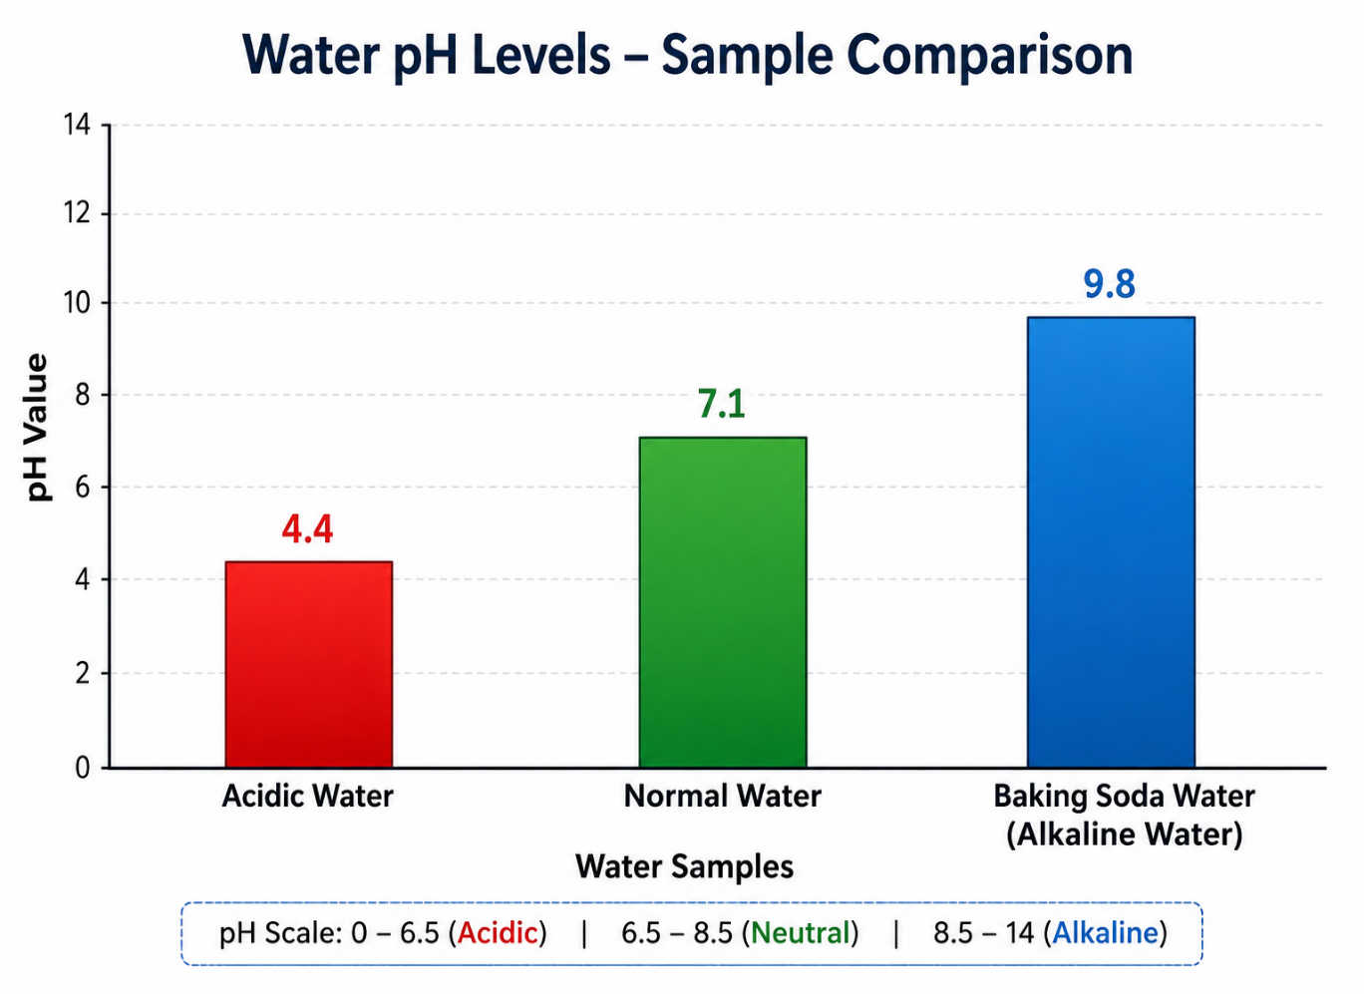

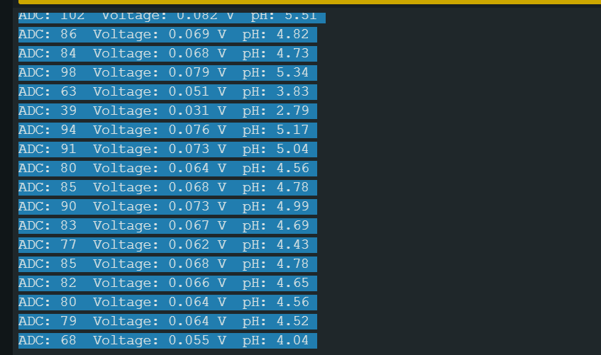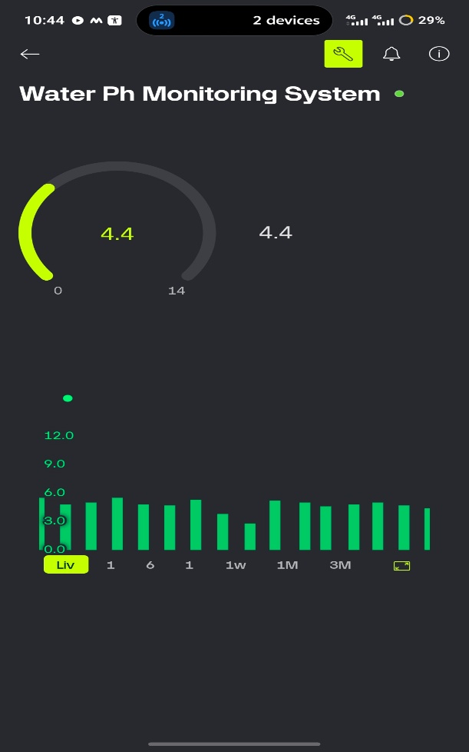

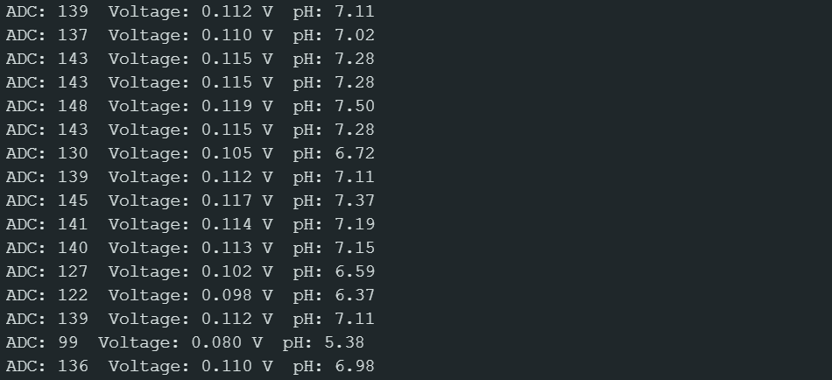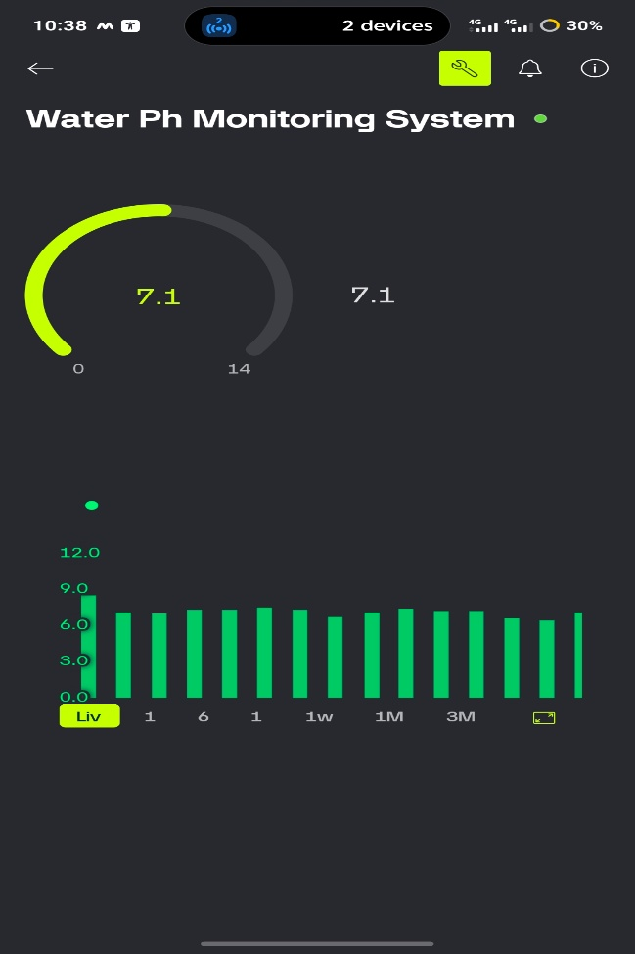
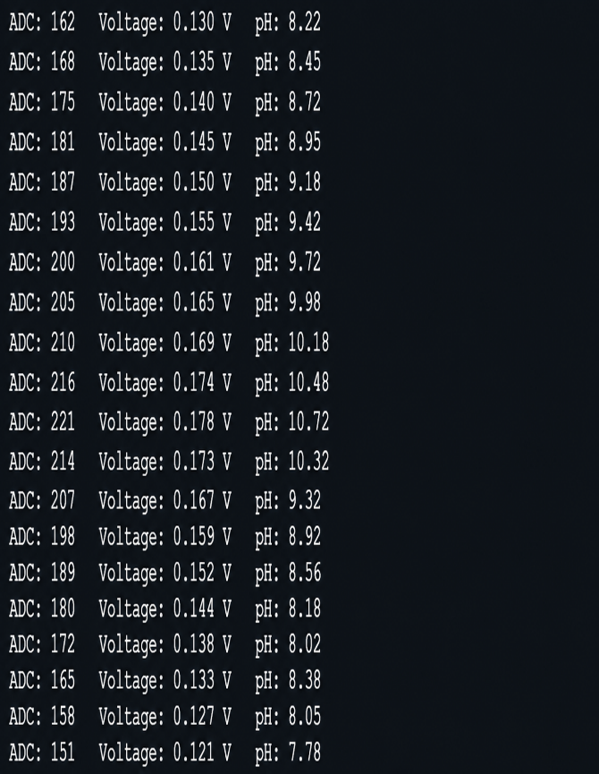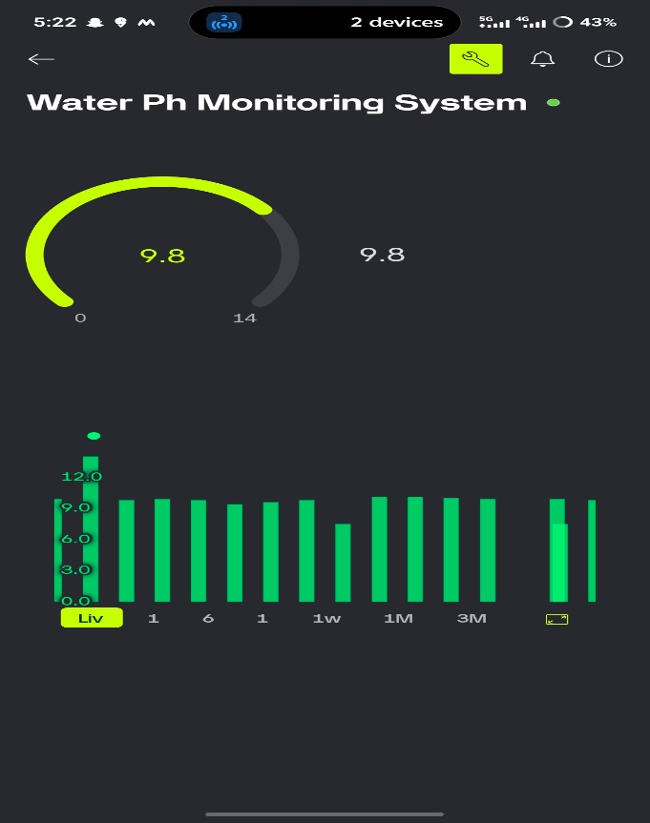

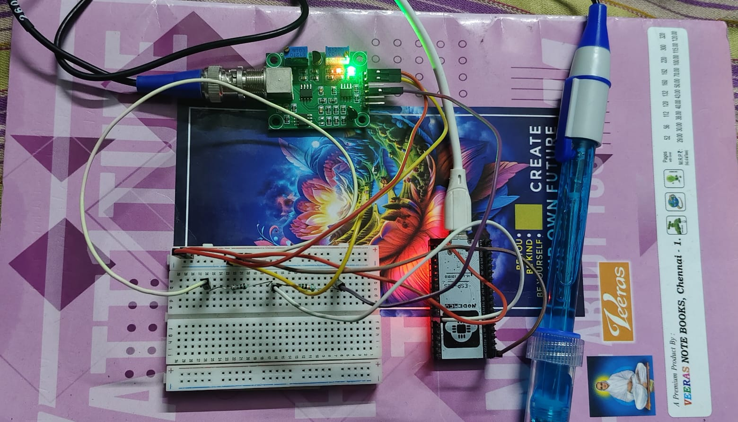

CHAPTER 5 – CONCLUSION, FUTURE WORK AND REFLECTION
5.1 Conclusion
The project successfully developed an IoT-based water pH monitoring system using an ESP32 and pH sensor. The system acquires the analog output from the pH sensor, processes the signal through the ESP32 ADC, converts the ADC reading into voltage, and calculates the corresponding pH value using the experimental calibration formula.
The calculated pH value is transmitted through Wi-Fi to the Blynk IoT platform, where it can be monitored remotely using the dashboard and graph. The system was tested with different water samples, including acidic water, normal water, and baking-soda water, and the readings showed different pH levels for the tested samples.
The system also includes an abnormal-pH alert mechanism for values below 6.5 and above 8.5. Overall, the developed prototype demonstrates the feasibility of combining pH sensing, ESP32 processing, IoT monitoring, and notification features in a low-cost water pH monitoring system.
5.2 Future Work
The system can be improved further by:
- Adding temperature measurement and compensation to improve pH accuracy.
- Improving sensor calibration using standard pH buffer solutions.
- Adding additional water-quality sensors such as TDS, turbidity, and temperature sensors.
- Adding data storage for maintaining long-term water-quality records.
- Improving the notification system with more configurable alert conditions.
- Developing a more advanced mobile dashboard for monitoring multiple parameters.
- Improving the stability and accuracy of the pH measurement circuit.
5.3 Professional Learning & Individual Reflection
New Knowledge Acquired
- Learned how to interface a pH sensor with ESP32.
- Learned how ESP32 ADC readings are converted into voltage.
- Learned how an experimental calibration formula is used to calculate pH.
- Learned how to connect ESP32 to Wi-Fi and Blynk IoT.
- Learned how to test, analyze, and visualize sensor readings.
Engineering & Professional Skills Developed
- Hardware interfacing and circuit debugging.
- ESP32 programming and ADC data processing.
- IoT dashboard configuration.
- Sensor testing and calibration.
- Technical documentation and presentation.

REFERENCES

- World Health Organization (WHO). (2022). Guidelines for Drinking-water Quality: Fourth Edition Incorporating the First and Second Addenda. Geneva: World Health Organization.
- Espressif Systems. (2025). ESP32 Series Datasheet. Espressif Systems.
- Espressif Systems. (2025). ESP32 Technical Reference Manual. Espressif Systems.
- Arduino. (2025). Arduino IDE Documentation. Arduino.
- U.S. Environmental Protection Agency (EPA). (2024). pH – Water Quality Monitoring and Assessment. United States Environmental Protection Agency.
- American Public Health Association (APHA), American Water Works Association (AWWA), & Water Environment Federation (WEF). (2017). Standard Methods for the Examination of Water and Wastewater (23rd ed.). Washington, DC.
- Boylestad, R. L., & Nashelsky, L. (2020). Electronic Devices and Circuit Theory (11th ed.). Pearson.
- Monk, S. (2017). Programming Arduino: Getting Started with Sketches (2nd ed.).
- McGraw-Hill Education.
- Schwartz, M. (2016). Internet of Things with Arduino Cookbook. Packt Publishing.
- Bahga, A., & Madisetti, V. (2014). Internet of Things: A Hands-On Approach. Universities Press.
- Borgia, E. (2014). The Internet of Things vision: Key features, applications and open issues. Computer Communications, 54, 1–31.
- Gubbi, J., Buyya, R., Marusic, S., & Palaniswami, M. (2013). Internet of Things (IoT): A vision, architectural elements, and future directions. Future Generation Computer Systems, 29(7), 1645–1660.
- World Health Organization. (2017). Water Quality and Health: Review of Turbidity and Microbial Safety. WHO Press.

APPENDIX A – DETAILED CALCULATIONS
A.1 ADC to Voltage Conversion
The ESP32 uses a 12-bit ADC, so the ADC range is 0–4095.
The voltage is calculated using:
Where:
- ADC = Average ADC reading
- 4095 = Maximum value of 12-bit ADC
- 3.3 V = ESP32 ADC reference voltage
A.2 Voltage to pH Conversion
The experimental calibration formula used in our program is:
Where:
- 7.0 = Reference pH
- 0.110 V = Calibration voltage
- 1.5/0.028 = Experimental calibration slope
A.3 Sample Calculation
From our recorded normal-water readings:
ADC = 137
First, convert ADC to voltage:
Now calculate pH:
pH=7.0+(0.110−0.110)×0.0281.5 , ​pH≈7.00​
Appendix B – Engineering Drawings / Schematics
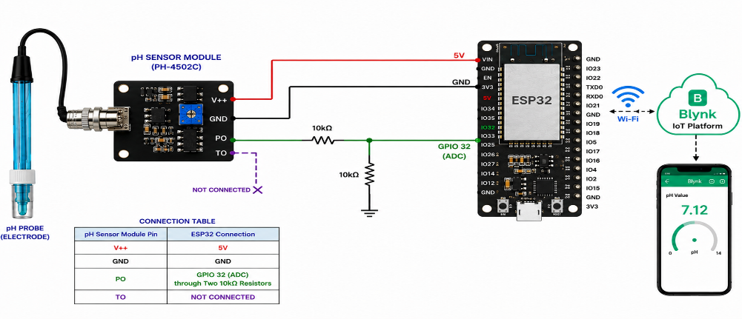
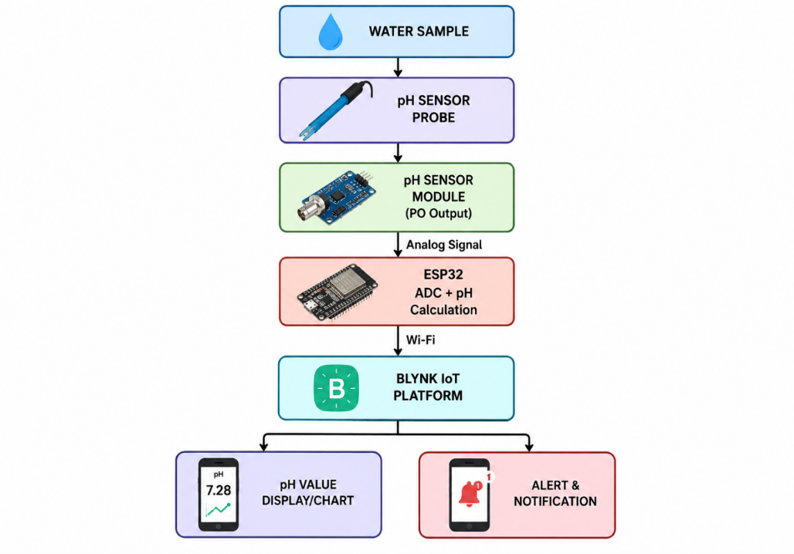
Appendix C – Source Code / Code Repository Information
Software Used
Software / Tool | Purpose
Arduino IDE | Writing and uploading the ESP32 program
ESP32 Board Package | Programming and controlling the ESP32
Blynk Library | Communication with the Blynk IoT platform
Wi-Fi Library | Establishing Wi-Fi communication
Blynk IoT Platform | Remote pH monitoring and notifications
Source Code
#define BLYNK_TEMPLATE_ID "TMPL3QYARxHib"
#define BLYNK_TEMPLATE_NAME "Water Ph Monitoring System"
#define BLYNK_AUTH_TOKEN "YOUR_BLYNK_AUTH_TOKEN"
#include <WiFi.h>
#include <BlynkSimpleEsp32.h>
char ssid[] = "YOUR_WIFI_NAME";
char pass[] = "YOUR_WIFI_PASSWORD";
#define PH_PIN 32
BlynkTimer timer;
int lowCount = 0;
int highCount = 0;
void sendPH()
{
long total = 0;
// Average 20 ADC readings
for (int i = 0; i < 20; i++)
{
total += analogRead(PH_PIN);
delay(10);
}
int adcValue = total / 20;
// ADC to voltage conversion
float voltage = (adcValue / 4095.0) * 3.3;
// Experimental pH calibration
float phValue =
7.0 + ((voltage - 0.110) * (1.5 / 0.028));
// Limit pH value
if (phValue < 0)
phValue = 0;
if (phValue > 14)
phValue = 14;
Serial.print("ADC: ");
Serial.print(adcValue);
Serial.print(" Voltage: ");
Serial.print(voltage, 3);
Serial.print(" V pH: ");
Serial.println(phValue, 2);
// Send pH value to Blynk
Blynk.virtualWrite(V0, phValue);
// Low pH detection
if (phValue < 6.5)
{
lowCount++;
}
else
{
lowCount = 0;
}
// High pH detection
if (phValue > 8.5)
{
highCount++;
}
else
{
highCount = 0;
}
// Low pH notification
if (lowCount == 3)
{
Blynk.logEvent(
"low_ph_alert",
String("Low pH detected: ") + String(phValue, 2)
);
}
// High pH notification
if (highCount == 3)
{
Blynk.logEvent(
"ph_alert",
String("High pH detected: ") + String(phValue, 2)
);
}
}
void setup()
{
Serial.begin(115200);
analogReadResolution(12);
WiFi.begin(ssid, pass);
Serial.print("Connecting to WiFi");
while (WiFi.status() != WL_CONNECTED)
{
delay(500);
Serial.print(".");
}
Serial.println();
Serial.println("WiFi connected!");
Blynk.config(BLYNK_AUTH_TOKEN);
Blynk.connect();
timer.setInterval(2000L, sendPH);
}
void loop()
{
Blynk.run();
timer.run();
}
Appendix D – Experimental / Raw Data
S.No. | Water Sample | ADC | Voltage (V) | pH
1 | Acidic Water | 102 | 0.082 | 5.51
2 | Acidic Water | 86 | 0.069 | 4.82
3 | Acidic Water | 84 | 0.068 | 4.73
4 | Acidic Water | 98 | 0.079 | 5.34
5 | Acidic Water | 63 | 0.051 | 3.83
6 | Normal Water | 128 | 0.103 | 6.63
7 | Normal Water | 127 | 0.102 | 6.59
8 | Normal Water | 137 | 0.110 | 7.02
9 | Normal Water | 132 | 0.106 | 6.81
10 | Normal Water | 130 | 0.105 | 6.72
11 | Baking Soda Water | 173 | 0.139 | 9.55
12 | Baking Soda Water | 174 | 0.140 | 9.60
13 | Baking Soda Water | 178 | 0.143 | 9.73
14 | Baking Soda Water | 181 | 0.146 | 9.86
15 | Baking Soda Water | 170 | 0.137 | 9.47

Summary
Water Sample | pH Range | Nature
Acidic Water | 3.83–5.51 | Acidic
Normal Water | 6.59–7.02 | Near Neutral
Baking Soda Water | 9.47–9.86 | Alkaline

